College Of computer training

2013

Twitter Management System

Documentation

Imtiaz Ahmad

Table of Contents

Introduction 4

Name of site & online location: 4

Goals of site: 4

Database: 4

Home (Products): 5

Header and Footer: 6

Sign-in: 7

New Tweet: 8

List My Tweets: 9

All Tweets: 9

Manage Products: 10

New Product: 11

Log-out: 12

Social Media Components: 12

Twitter: 12

Facebook: 13

Browser Compatibility: 14

Device Compatibility: 14

Issues: 15

Future features predicted : 16

Conclusion: 16

References: 17

Sign-in Details: 17

Twitter Management System

# Introduction

Twitter Management System is an application for online shopping website to tweet the new arrival and products to the people. The application uses the twitter bootstrap framework which is a responsive design, which makes the application to be served on a variety of media such as desktop, laptop, mobile phones, ipads etc. The bootstrap css resizes itself according to be screen size of the media it is served on. Contains A products page containing listing all the available products. Once the administrator logs in he can perform a variety of tasks like manage products, tweet about the newly added products and view all the previous tweets. All the products are stored in the database. Administrators are able to view, edit, delete and add new products.

# Name of site & online location:

Site name is Twitter Management System and it is available online in URL Introduction

<http://naturegardenbuilder.com/>

# Goals of site:

The Goal of this site is to manage products and help head of marketing department to share product details to public. A system that makes it easy to use the power of social media to enhance and expand business. An interactive web application to allow administrators to manage the products. And share and advertise them on a variety of social media sites like twitter and facebook.

# Database:

This application has 3 tables: users, tweets and products. Users table stores the login information of users. Products table stores the products and tweets table is used to store all the tweets about products. Mysql is used to create the database and sql is was used to query the database. DB connection details available in config/dbconfig.php

Twitter connection details available in config/twitterconfig.php

# Home (Products):

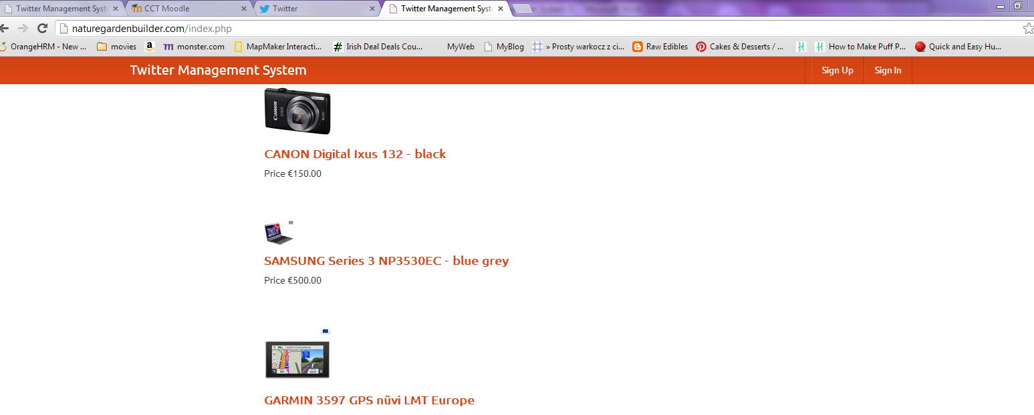

Above screenshot represents the home page of our application where a not logged in user can see the different available products, their names, pictures and prices. Once the user clicks on of the products it open up more details about the products in a new page. The image below represents a products with detals. Just below the product’s details there are two social media components which are facebook share and twitter tweets. User can share the product to their facebook timeline and tweet about it on using their twitter timeline.

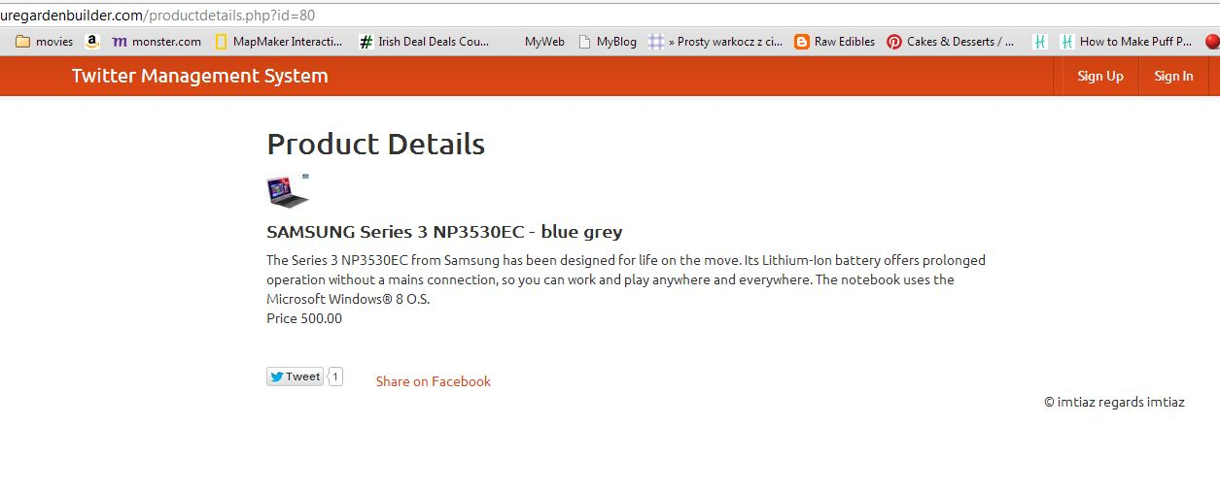

On the top right corner there are signup and login buttons.

# Header and Footer:

Statuary header and footer are present on all the pages. Code for header and footer can be found in header.php and footer.php which are included on top of every page.

Sign-up:

The signup page contains a simple form which asks users to choose a user name, email and password. These details are stored in the users table in our database once the user clicks signup button located at the bottom of form.

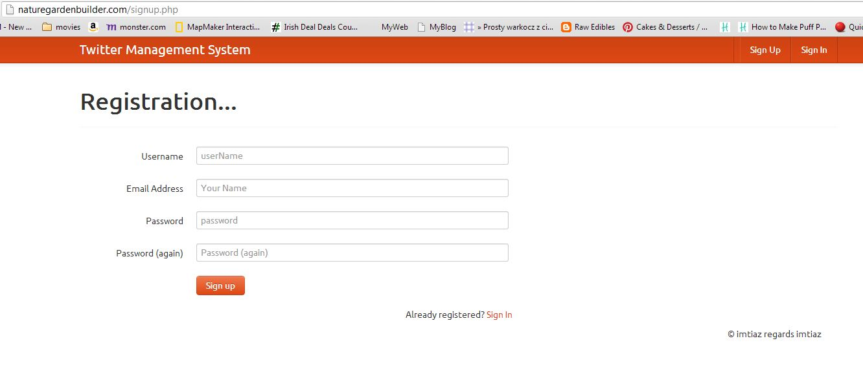

The following code is used to insert values in the user table when submit button is pressed.

if(isset($_POST['commit']))

{

extract($_POST);

mysql_query("INSERT INTO `users`(email,username,password)VALUES('$emailAdd','$userName','$password')");

$_SESSION['userid'] = mysql_insert_id();

header("Location:home.php");

}

# Sign-in:

The sign-in page requires user to enter their user name which they provided at the time of registration and their password to login to website and to access the full functionality and administrative controls. User must provide a valid username and password to login, if the fail to do so they will not be able to login. Once correct login details are provided, user is brought to the following page which has provides four main options to the user.

1. New Tweet (Where user can write a new tweet)
2. List My Tweets (To allow user to list their tweets)
3. All Tweets (User can view the list of all tweets they tweeted)
4. Manage Products (To manage the products)

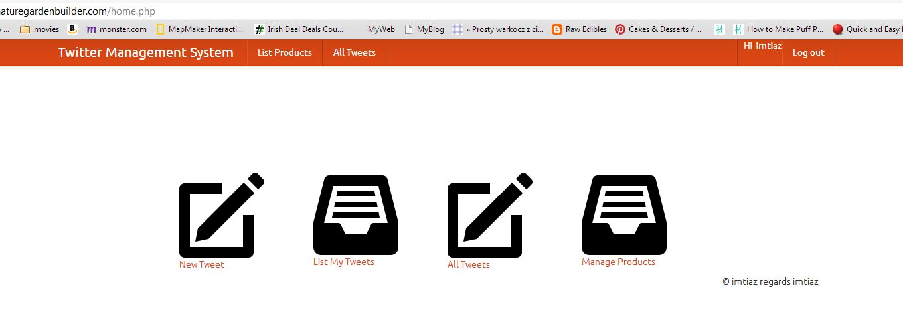

# New Tweet:

The new tweet button allows users to enter a new tweet that will be displayed on their twitter timeline. It could be of any sale offers, new products of just an announcement to the users.

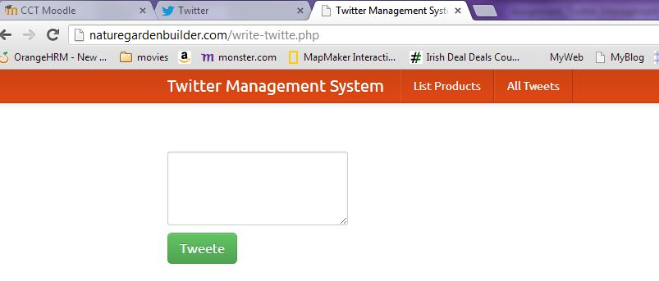

A simple text box with where users can write their tweet and by pressing “tweet” button at the bottom submits the tweet to user’s twitter timeline.

# List My Tweets:

List my tweets button displays all the tweets by that particular user with the date and time the tweet was entered.

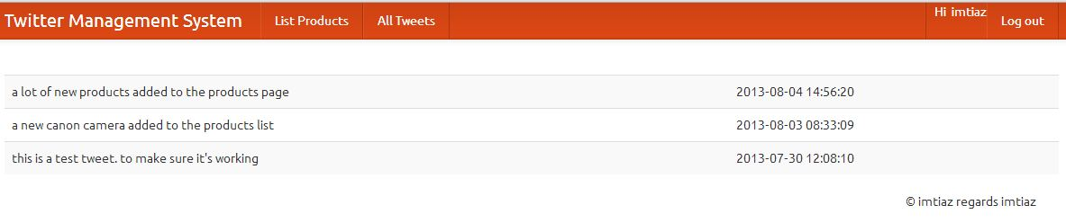

The query below fetches the tweets of any user from the database and displays in form of a list.

$result = mysql_query("SELECT * FROM tweets WHERE userid=$user_id ORDER BY tweetid DESC ");

# All Tweets:

This button lists all the tweets from every single user with their username and date and time the tweet was entered.

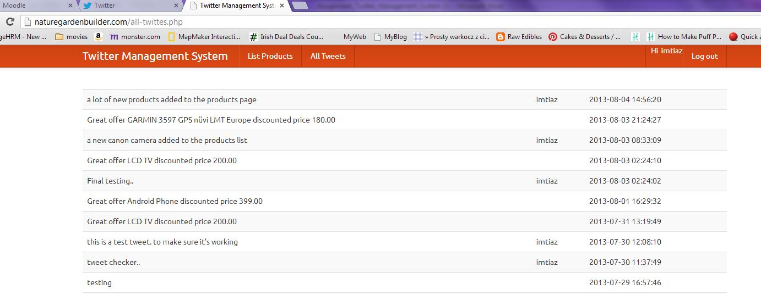

# Manage Products:

Manage products page gives a variety of different managing options to the user. All the available list of products is presented to the user with options on the front like edit, delete, and tweet. User can edit details of a product of delete it from the list or tweet about a particular product displayed. Add new product button at the bottom allows to enter more products in the list.

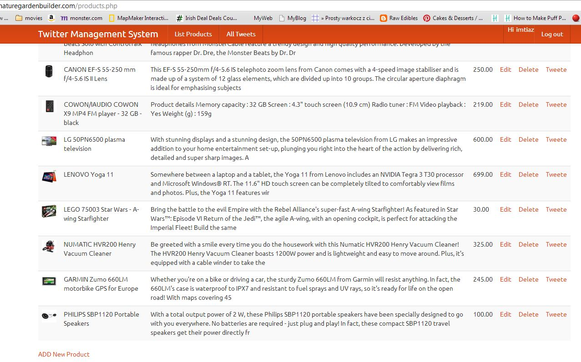

# New Product:

This option allows registered user to add new product in the list of existing products. User is presented with a form containing a number of different options to fill out when pressed “enter” will store all the information provided to the products table in the database. It allows user to upload a picture of the product which will be displayed in the products list.

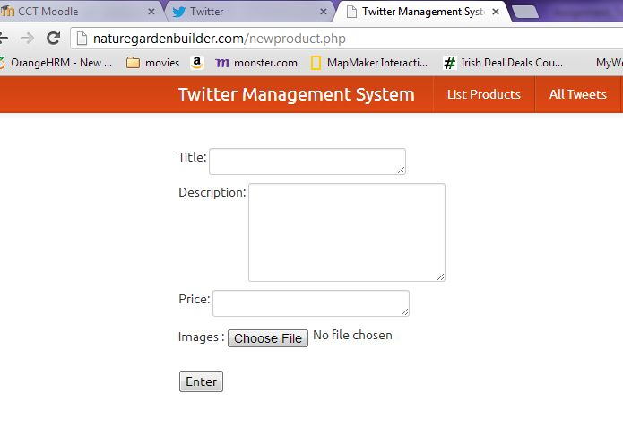

<form enctype="multipart/form-data" method="post" action="products.php">

Title:

<textarea name="product_name" cols="50" rows="1"></textarea>

<br>

Description:

<textarea name="product_desc" cols="50" rows="5"></textarea>

<br>

Price:

<textarea name="price" cols="50" rows="1"></textarea>

<br>

Images : <input type="file" name="photo"><br>

<br>

<input type="Submit" name="submit" value="Enter">

</form>

# Log-out:

Log out is a simple php function used to terminate a session. When clicked user is directed back to the index page. Code below shows the logout function.

<?php if(array_key_exists("logout", $_GET)) { session_start(); unset($_SESSION['userid']); header("location: index.php"); }?>

# Social Media Components:

User can share and tweet about any listed product, using this option will share the product on their twitter and facebook timeline. Following api codes were used to integrate this functionality.

## Twitter:

<a href="https://twitter.com/sharee?text=<?php echo urlencode($twitte_msg); ?>&" class="twitter-share-button" data-text="<?php $product_name; ?>" data-lang="en">Tweet</a>

<script>!function(d,s,id){var js,fjs=d.getElementsByTagName(s)[0];if(!d.getElementById(id)){js=d.createElement(s);js.id=id;js.src="https://platform.twitter.com/widgets.js";fjs.parentNode.insertBefore(js,fjs);}}(document,"script","twitter-wjs");</script>

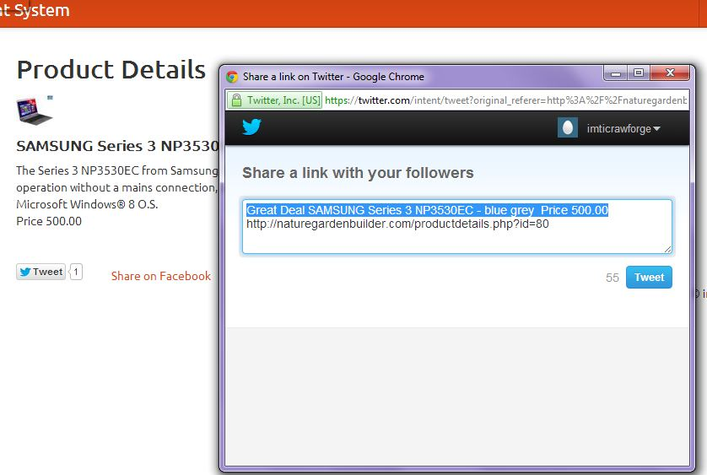

## Facebook:

<a href="https://www.facebook.com/sharer/sharer.php?u=http%3A%2F%2Fnaturegardenbuilder.com" target="_blank">

Share on Facebook

</a>

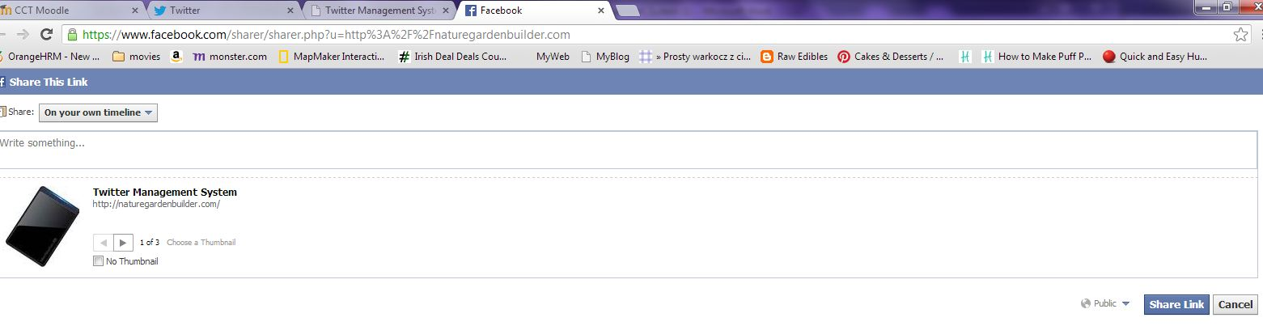

# Browser Compatibility:

I have tested in chrome, firefox and IE and it works fine in all of them.



# Device Compatibility:

Laptop and mobile phone tested.



# Issues:



1-Application get logs out when moved to product management page. The root cause of this issue is “register_globals” set on in my host provider.

By turning off register global in php.ini this issue would be fixed.

register_globals = off

2-At the sign-in page there is an option if the users forgets the password they can retrieve it using their email address, which is not functional at this stage because of time constraints.

3-Didn’t register a new domain instead used already registered domain which does not match the content. As the free hosting did not allow me to register more than one domain.

# Future features predicted :

* We can implement scheduled and recurring tweet
* We can also implement review and approve process where customer relation manager approve tweet before it sends
* Convert into this a simple shopping site by providing view cart and checkout option
* Design and layout can be improved.
* Products can be divided into categories which will make it easy for customers to find when they are looking for.
* Search button would help greatly in usability of the application.
* Different pages like home, contact us, about us can be implemented.

# Conclusion:

I have learned twitter integration, bootstrap and facebook. The power of social media can be greatly used to enhance an online business. Social media provides easy integration of their components to different websites. This application has the basic functionality which can be improved to make it an online store. Using of bootstrap makes it compatible with a lot of different devices like laptop, mobile phones, tablets etc. If given more time it can be greatly improved.

# References:

Twitter bootstrap: <http://getbootstrap.com/2.3.2/>

Twitter integration :<https://github.com/abraham/twitteroauth>

To connect twitter, we need Consumer_key, consumer_secret, oauth_token and oauth_secret which can be generated using <https://dev.twitter.com/apps>

<https://developers.facebook.com/>

[www.twitter.com](http://www.twitter.com)

www.stackoverflow.com

# Sign-in Details:

<http://naturegardenbuilder.com/index.php>

Id: [imtiaz818@gmail.com](mailto:imtiaz818@gmail.com)

Password:12345

GitHub Repository:

<https://github.com/imtiaz818/Twitter-management-system>